Dear wonderful parent of a divine child, attend this free seminar on parenting. In this free seminar you will witness something amazing, Unimaginable and Miraculous feats of mind power. Following are some of the highlights of the seminar, attend seminar and get to know more on parenting. (Age GROUP of child : 2 to 7 years )
Types of parenting
- What is your parenting style?
- What style of parenting is comfortable for you?
- Is your child comfortable with your parenting style?
Home work without tears
- How to motivate your child to do its best
- How to communicate to get the home work done
- How to help your children to study successfully
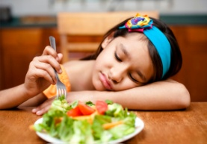
Eating habits of your child
- When to eat and how much to eat?
- How to inculcate eating habits in your child?
- Healthy tips for healthy life style for your child?
Factors affecting relationship
- How does talent make difference in his/her child?
- Who are the targets for your divine child in her life?
- What is the thinking style of your style to gel with others?
TV , Games and your child
- How to motivate your child to stop watching TV?
- How to help your child in making him/her love studies?
- What does science say about children with TV and Video games?
Anger Management in parenting

- Are anger good emotions or not?
- How to control one’s anger without strain?
- Why does child get angry?
Seminar venue : Gv academy school , (city campus)
Near collector office, e rode.
Date and time : 26 .01. 2014 , (10.00 a.m to 11.30 a.m)
For Free registration call : 9843511854

